Policy Issued:  1/1/19  Last Revised:  1/1/19  Contact Information  If you have questions about any of our Company policies please contact Rachel Ackerman at 608-664-6122. | OneNeck IT Solutions Employee Handbook  Policy 203: Work Week, Work Schedules & Overtime  Purpose  This policy establishes OneNeck's defined regular work week, work schedules and overtime guidelines to ensure compliance with federal and state wage and hour regulations. This policy also sets the minimum standards for hours worked and wages paid to employees.  Scope  This policy addresses the following topics:  - Work Week  - Work Schedules  - Overtime Hours  Work Week  The defined payroll work week is Sunday at midnight through Saturday 11:59 pm. Hours worked are defined as either Standard "Traditional" or Non-Standard/Alternative.  Standard "Traditional" Work Week: Generally, a standard work week includes a Monday through Friday schedule, with 8-hour days, ensuring an employee works between the core hours of 9:00am and 3:00pm. It also could include a regular schedule such as 6:00am-3:00pm, 7:00am-4:00pm or 9:00am-6:00pm.  Non-Standard/Alternative Work Schedule (AWS): AWS's include, but are not limited to, regular (consistent) schedules outside the standard "traditional" work week hours. One example that may be adopted by some departments are Compressed Work Weeks (CWW) where 40 hours are worked in a week but the employee works more than 8 hours each day in order to have a consistent scheduled "earned" day/half-day off on a weekly or bi-weekly basis. The regular part-time classification, also known as Reduced Work Schedules, also falls within this category. Employees should talk with their Supervisor for more information.  Work Schedules  Flexible scheduling has been shown to increase productivity, help with retention, reduce overtime costs, and improve employee satisfaction.  Understandably, not all employees or positions are eligible or will be approved for an alternative work schedule because of job responsibilities, performance or other criteria as determined by department leaders. Leaders are responsible for approving employees' work schedules, ensuring situations are working successfully and that coverage of work is adequate in addition to timely notifying Human Resources of work schedule changes.  Employees working an Alternative Work Schedule should see the Paid-Time Off Benefits section listed below for specific directions on keying time for vacation, personal days, sick leave, or holiday hours.  Flexible Work Hours  Flextime can be applied to Standard "Traditional" or Non-Standard "Alternative" work schedules and allows an employee to work a flexible schedule as long as they work the core hours of 9:00am and 3:00 pm. An obvious exception to this guideline is employees who are required to work late, evening, or night shifts. It is important that employees participate in all team meetings and required professional development which may require working regular business hours on occasion.  Exempt-level (salaried) employees are paid to perform the responsibilities of their position and a greater emphasis is placed on completing work assigned rather than working a specified number of hours meaning that exempt employees may need to work more than 40 hours per week.  Paid-Time Off Benefits  Employees working an AWS will need to key into time entry the same number of paid-time off (PTO) hours they are scheduled to work. For example, a full-time employee working a 4x10 (four ten-hour days each week) work schedule will need to key 10 vacation, personal day or sick hours. Work schedules may not be changed in order to reduce the amount of PTO hours that need to be keyed in these instances. For holidays, only the maximum number of hours for each holiday should be keyed:  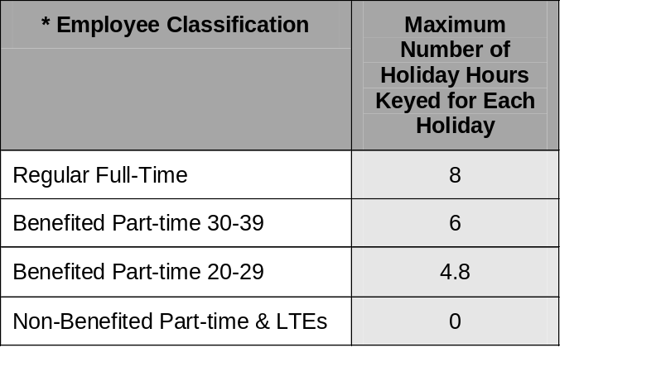  Still using the 4x10 example, on a day of a Company-observed holiday, a full-time employee will need to key 2 hours as personal day or vacation to account for their full 40 hours that week. The reason for this is because employees are only eligible for a total of 48 holiday hours per year and if they key 10 for any holiday, that will exhaust their holiday hours before the last holiday in the year.  Part-Time Reduced Work Schedule  Part-Time Reduced Work Schedules can be approved depending upon job responsibilities, customer commitments and employee performance. Part-Time Reduced Work Schedules provide flexibility and a better work/life balance by allowing time off on a regular basis by working less than 40 hours/week. Part-time schedules will result in a pay reduction and benefits eligibility impacts – see Policy 611: Employee Classification.  If, at any time, a leader determines a part-time schedule is not working, it can end at any time. Also, employees need to be flexible for unforeseen needs and able to respond in a timely manner to customer requests.  Break/Meal Periods  Federal law does not require OneNeck to provide breaks or meal periods, however, it is very beneficial for productivity to do so. Federal law only considers break time, lasting 5-20 minutes, as compensable hours. Meal periods lasting at least 30 minutes are not considered work time and are not compensable.  Certain states, however, have state-specific break and meal period requirements. Please see the State Specific Break and Meal Period Summary for more information.  In accordance with the Patient Protection and Affordable Care Act (also known as "Health Care Reform Plan") adopted in March 2010, OneNeck provides "reasonable" break periods and private space for mothers to express milk for their infants up to age 1. Employees need to notify their leader with requests.  Non-Exempt Employees  Overtime  Non-exempt (hourly) employees are eligible for overtime compensation for hours worked over 40 in a week (unless state regulations apply). Employees should not begin work prior to or after their scheduled work hours or work during lunch without their leader's pre-approval. Employees are responsible for recording all overtime into time entry. Leaders will attempt to provide reasonable notice when overtime is needed.  Only holiday hours are included in hours worked for overtime purposes. Sick, vacation, personal days or time keyed to Time Off Award is not included in hours worked for overtime. Non-exempt employees should not exceed 8 hours of time worked (assuming they work a standard 8 hours shift) on a day when keying time to Time Off Award and/or when utilizing vacation, personal, or sick time.  Leaders of non-exempt employees working a Compressed Work Week (CWW) need to ensure the CWW schedule does not result in overtime hours. For example, because a 9x9 work schedule results in more than 40 hours' work in week 1, this option is not available to non-exempt employees. Additionally, employees in a state requiring overtime pay for hours worked over 8 in a day, such as California, are also ineligible for a CWW schedule.  Next Policy

